Les clubs Lagotto Romagnolo de par le monde…

CANADA | Lagotto Romagnolo Club of Canada |  | http://lagottoromagnoloclubofcanada.ca/
 |  |  | https://www.facebook.com/groups/lrcoc/
 |  |  | https://www.ckc.ca/fr
https://www.facebook.com/CKC4thedogs/

https://www.ckc.ca/fr

FRANCE | 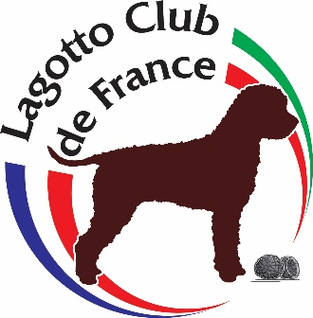  Lagotto Club de France  (LCF) | 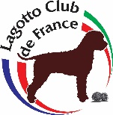
 |  |  | https://www.facebook.com/lagottoclubdefrance/?fb_dtsg_ag=Ady15KeROJRDlfa_hoqN1lt6-ejVEbjK2D-AN2ob-CEpbw%3AAdxD7sZ3nGZdkjnPk7HhP0muOHIet60w-yxPn3p62XpRQg
https://www.centrale-canine.fr/
https://www.facebook.com/Soci%C3%A9t%C3%A9-Centrale-Canine-135160526597257/
http://www.fci.be/fr/
https://www.facebook.com/FederationCynologiqueInternationale/

GRANDE BRETAGNE |  |  | http://www.lagottoromagnoloclubofgb.co.uk/  http://www.lagottoromagnoloclubofgb.co.uk/  https://www.facebook.com/lrcgb
http://www.lagottoromagnoloassociation.co.uk/

https://www.facebook.com/Lagotto-Romagnolo-Association-LRA-291234181347858/
 |  |  | https://www.thekennelclub.org.uk/
https://www.facebook.com/TheKennelClubUK/

https://www.thekennelclub.org.uk/

HONGRIE | 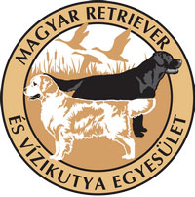  CLUB ITALIANO LAGOTTO  (CIL) | 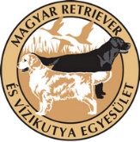 | http://retrieveregyesulet.hu/lagotto-romagnolo/?lang=en
https://www.kennelclub.hu/
https://www.facebook.com/Soci%C3%A9t%C3%A9-Centrale-Canine-135160526597257/
http://www.fci.be/fr/
https://www.facebook.com/FederationCynologiqueInternationale/

ITALIE | 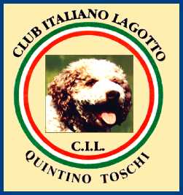  CLUB ITALIANO LAGOTTO  (CIL) |  | http://www.lagottoromagnolo.org/
 |  |  | https://www.facebook.com/groups/528795490473192/?fb_dtsg_ag=AdwBysTZU2_Pb-N4bx_yAzlDFdeypIyMqMb8niPtuvrTgQ%3AAdz_CgC9nHFMTjsR0dnbbY0B5Fn-sI2PigmqW0XACe5m1A
 |  |  | http://www.enci.it/
https://www.facebook.com/Soci%C3%A9t%C3%A9-Centrale-Canine-135160526597257/

http://www.fci.be/fr/

NEDERLAND  PAYS-BAS  HOLLANDE | 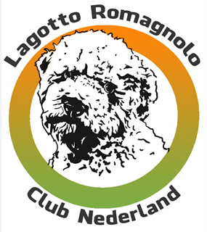  CLUB ITALIANO LAGOTTO  (CIL) | 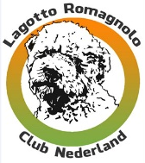 | http://www.lagotto.nl/
 |  |  | https://www.facebook.com/Lagotto-Romagnolo-Club-Nederland-LRCN-308778965820396/?fb_dtsg_ag=AdwBysTZU2_Pb-N4bx_yAzlDFdeypIyMqMb8niPtuvrTgQ%3AAdz_CgC9nHFMTjsR0dnbbY0B5Fn-sI2PigmqW0XACe5m1A
 |  |  | https://www.houdenvanhonden.nl/
https://www.facebook.com/raad.vanbeheer

http://www.fci.be/fr/

SERBIE | 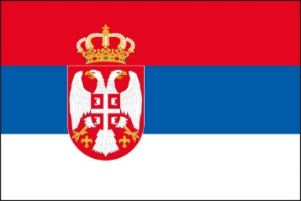  ROMAGNOLO LAGOTTO SRBIJA CLUB
 |  |  | https://www.facebook.com/groups/Lagotto.Club.Srbija/
 |  |  | https://ksrs.rs/
https://www.facebook.com/Kinoloski-Savez-Srbije-306058469461789/

http://www.fci.be/fr/

SUISSE | LAGOTTO CLUB  SCHWEIZ - SUISSE |  | http://lagottoclub.ch/LeLagottoRomagnolo/tabid/207/language/fr-FR/Default.aspx
 |  |  | https://www.facebook.com/groups/697554283604165/?fb_dtsg_ag=AdwBysTZU2_Pb-N4bx_yAzlDFdeypIyMqMb8niPtuvrTgQ%3AAdz_CgC9nHFMTjsR0dnbbY0B5Fn-sI2PigmqW0XACe5m1A
 |  |  | https://www.skg.ch/
 |  |  |  | http://www.fci.be/fr/

USA  ETATS-UNIS | 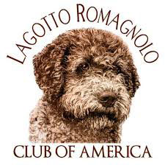  LAGOTTO CLUB  OF AMERICA | 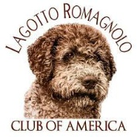 | https://www.lagottous.com/
 |  |  | https://www.facebook.com/groups/LagottoRomagnoloClubofAmerica/
 |  |  | https://www.akc.org/
https://www.facebook.com/AmericanKennelClub/

https://www.akc.org/

http://www.larousse.fr/encyclopedie/images/Drapeau_du_Canada/1009478

